**property() Function:**

- A more Pythonic way to use getters and setters in object-oriented programs  
- *getters* and *setters* are a useful way to achieve *encapsulation* (a way of preventing data from being directly modified)  
- We can define a private attribute and use getters and setters to expose a public means of reading and modifying a class attribute value  
- Also allow us to create more complex behavior such as limiting access under certain conditions or imposing restrictions on allowable ranges of values for an attribute  
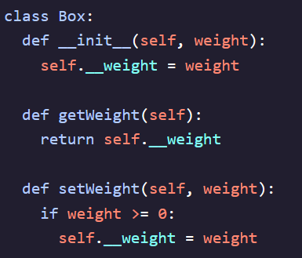   
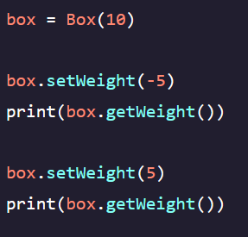 - Need to call methods instead of directly interacting with *weight* variable





- *property()* – A built-in-function that allows us to directly interact with a defined variable but still benefit from the complex behavior of methods such as the weight restriction  
- accepts four positional arguments: *fget* (getter)*, fset* (setter)*, fdel* (delete)*,* and *doc* (docstring for attribute  
  
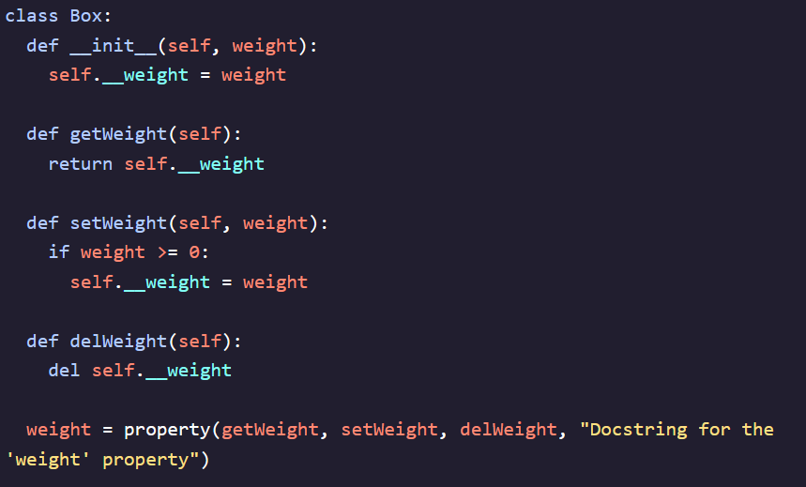 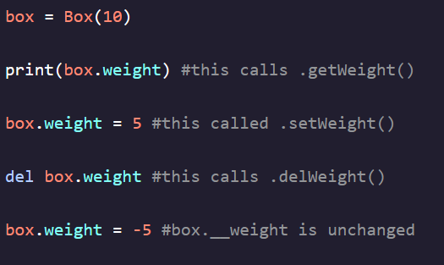

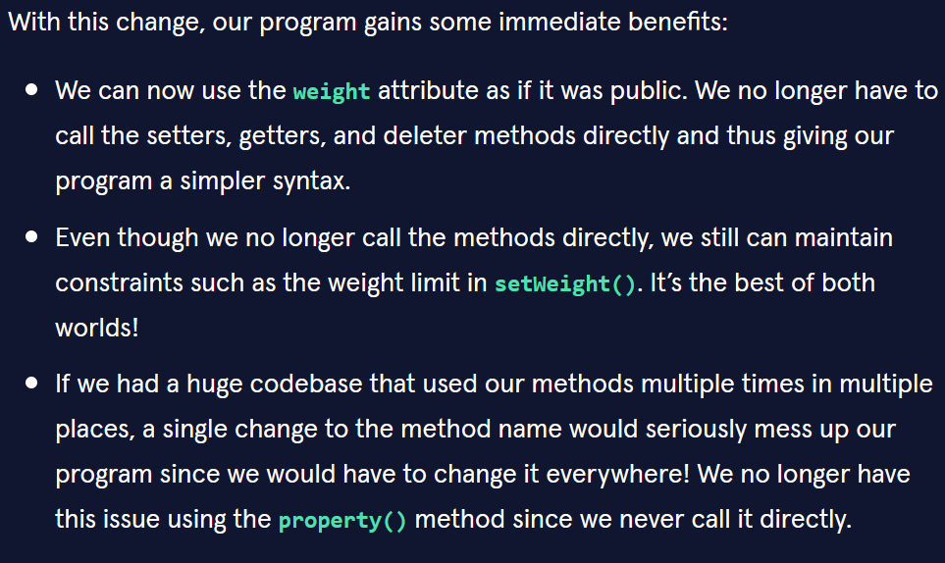

**@property Decorator:**

- The most Pythonic way to use getters, setters, and deleters  
